Use structured reasoning / step-by-step prompting to generate:
- a) Automation Framework Architecture
Prompt Used:
Generate Automation Framework Architecture for Data validation between oracle servers for 1M records using python language using primary key/unique key combination Ask MCQ questions, if you have questions on db or process, NO Assumptions The architecture should be framed as a scheduled one, Share the steps in a document as steps for easy understanding.
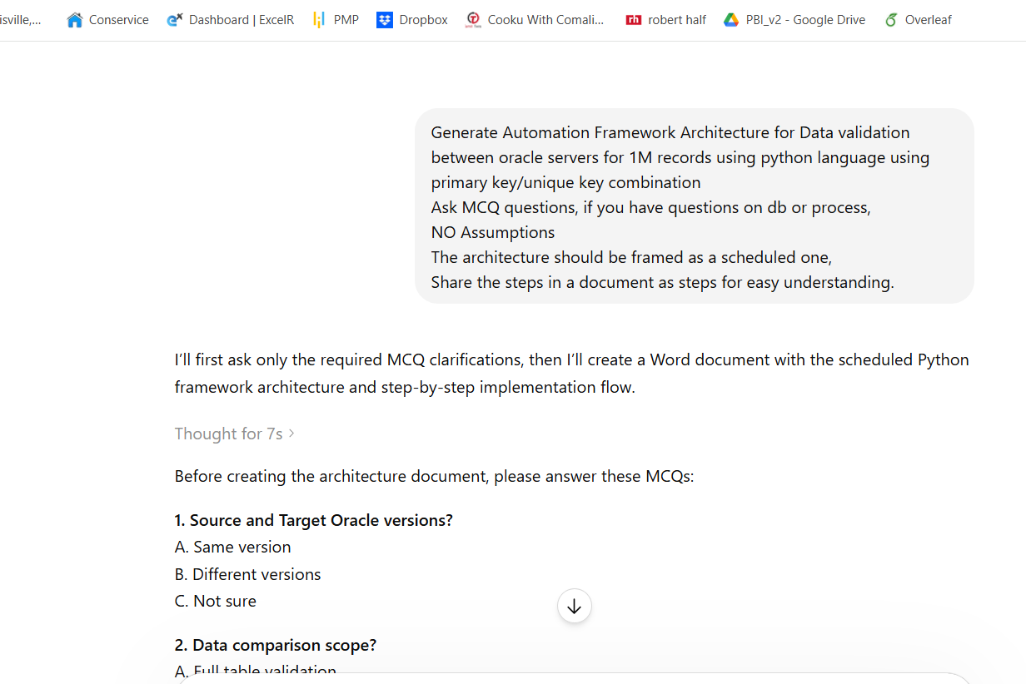
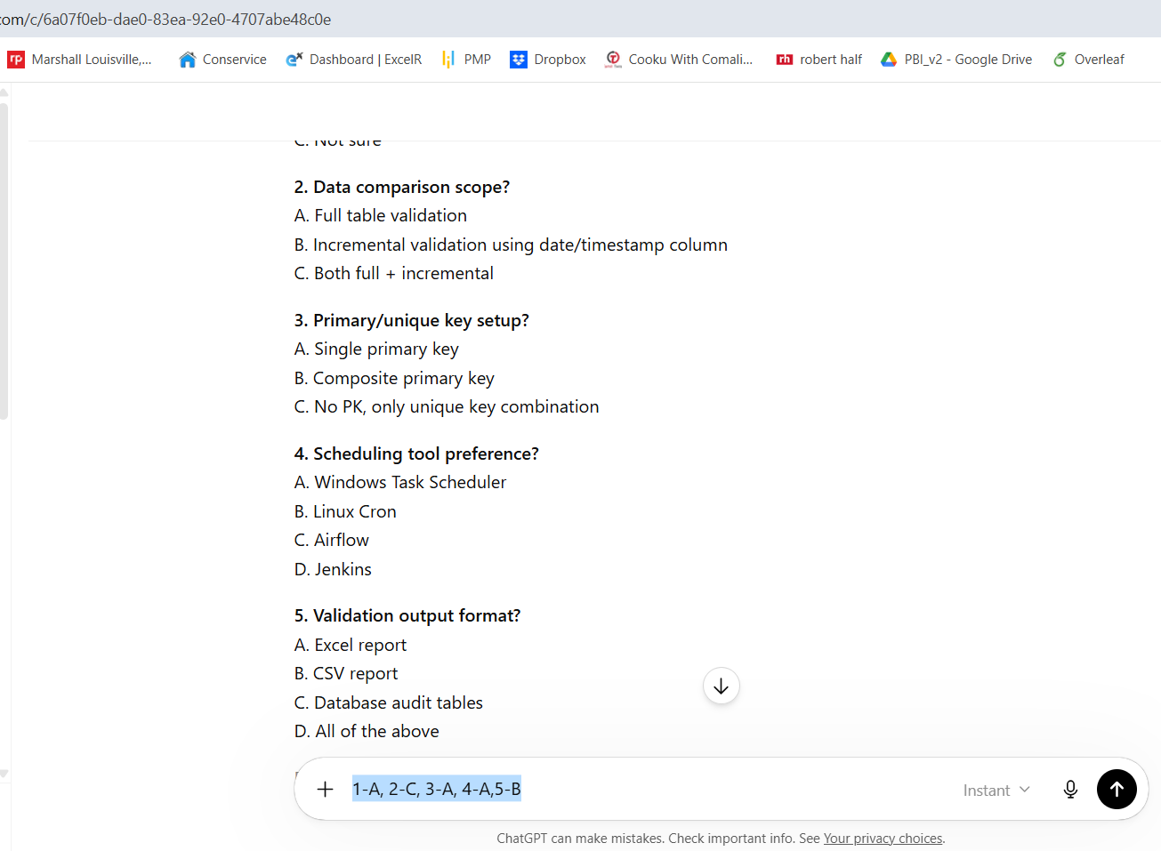
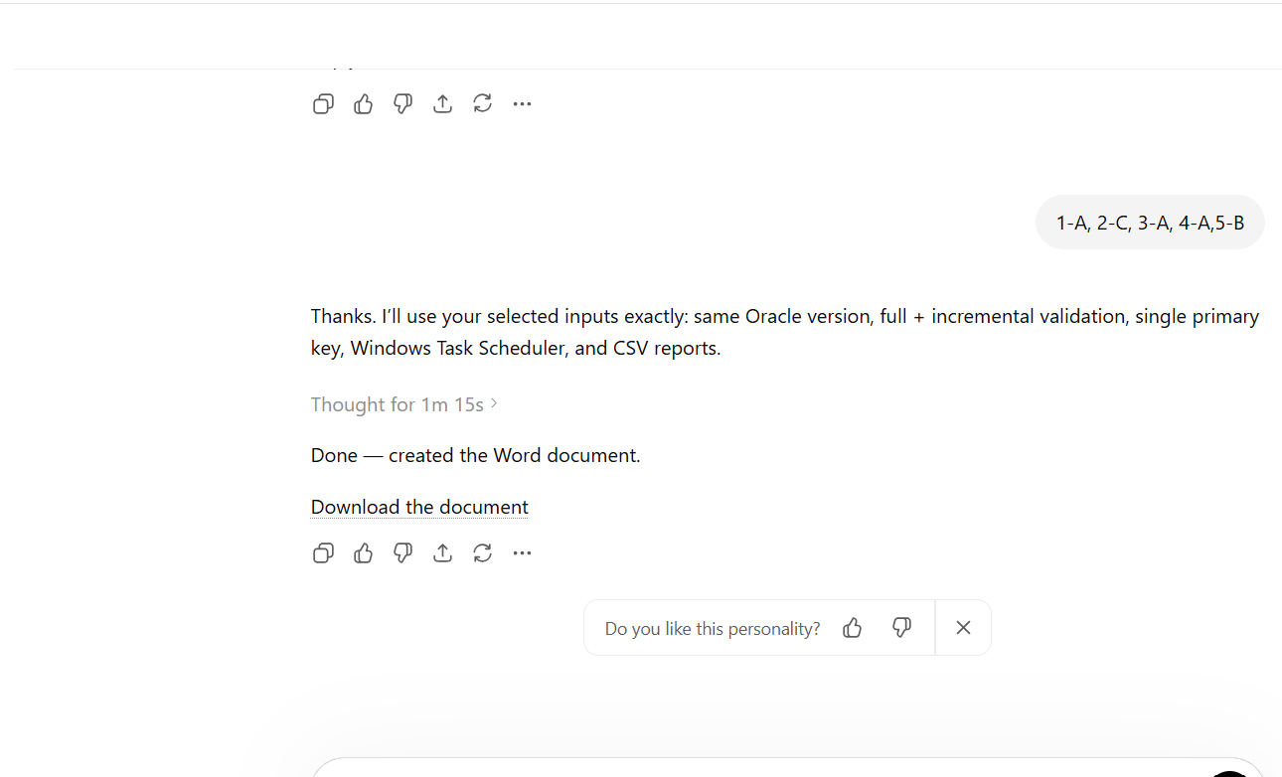
The attached document has all detailed steps required for implementation of architecture from scratch.

